**3**

**Programming with Java Operators and Strings**

**Understand Fundamental Operators**

Java operators are used to return a result from an expression using one, two, or three operands. Operands are the values placed to the right or left side of the operators. Prefix- and postfix-increment and prefix- and postfix-decrement operators use one operand. The conditional ternary operator (?:) uses three operands. All other operators use two operands.

The following topics will be covered in these pages:

* Assignment operators
* Arithmetic operators
* Relational operators
* Logical operators
* Operator precedence

**Assignment Operators**

Assignment operators are used to assign values to variables.

|  |  |
| --- | --- |
| = | Assignment operator |

**Compound Assignment Operators**

|  |  |
| --- | --- |
| + = | Assignment by addition operator |
| * = | Assignment by subtraction operator |

Although the use of compound assignment operators cuts down on keystrokes, it is generally good practice to use the “longhand” approach since the code is clearly more readable.

*It is common to represent assignments in pseudo-code with the colon and equal sign characters (for example, A := 20). Notice that := looks similar to +=, -=, and other Java assignment operators such as *=, /=, and %=. Be aware, however, that the pseudo-code assignment representation (:=) is not a Java assignment operator, and if you see it in any Java code, it will not compile.*

**Arithmetic Operators**

**Basic Arithmetic Operators**

|  |  |
| --- | --- |
| + | Addition (sum) operator |
| - | Subtraction (difference) operator |
| * | Multiplication (product) operator |
| / | Division (quotient) operator |
| % | Modulus (remainder) operator |

**Prefix-Increment, Postfix-Increment, Prefix-Decrement, and Postfix-Decrement Operators**

|  |  |
| --- | --- |
| ++x | Prefix-increment operator |
| --x | Prefix-decrement operator |
| x++ | Postfix-increment operator |
| x-- | Postfix-decrement operator |

Prefix-increment and prefix-decrement operators provide a shorthand way of incrementing and decrementing the variable by 1. Rather than creating an expression as y=x+1, you could write y=++x. Similarly, you could replace the expression y=x-1 with y=--x. This works because the execution of the prefix operators occurs on the operand prior to the evaluation of the whole expression. Postfix-increment and postfix-decrement characters execute the postfix operators after the expression has been evaluated. Therefore, y = x++ would equate to y=x followed by x=x+1. And y = x-- would equate to y=x followed by x=x-1.

Note that y=++x is not exactly equivalent to y=x+1, because the value of x changes in the former but not in the latter. This is the same for y=--x and y=x-1.

The prefix-increment operator increments a value by 1 before an expression has been evaluated.

|  |
| --- |
| int x = 10;  int y = ++x ;  System.out.println("x=" + x + ", y=" + y); // x= 11, y= 11 |

The postfix-increment operator increments a value by 1 after an expression has been evaluated.

|  |
| --- |
| int x = 10;  int y = x++ ;  System.out.println("x=" + x + ", y=" + y); // x= 11, y= 10 |

The prefix-decrement operator decrements a value by 1 before an expression has been evaluated.

|  |
| --- |
| int x = 10;  int y = --x ;  System.out.println("x=" + x + ", y=" + y); // x= 9, y= 9 |

The postfix-decrement operator decrements a value by 1 after an expression has been evaluated.

|  |
| --- |
| int x = 10;  int y = x-- ;  System.out.println("x=" + x + ", y=" + y); // x= 9, y= 10 |

**Relational Operators**

**Basic Relational Operators**

|  |  |
| --- | --- |
| < | Less than operator |
| <= | Less than or equal to operator |
| > | Greater than operator |
| >= | Greater than or equal to operator |

These operators are used to compare integers, floating points, and characters.

Remember that characters (that is, char primitives) accept integers (within the valid 16-bit unsigned range), hexadecimal, octal, and character literals.

|  |
| --- |
| boolean b9 = 'A' < 'B'; //Character literals  boolean b10 = '\u0041' < '\u0042'; //Unicode literals  boolean b11 = 65 < 66; //Integer literals that fit in a char  boolean b12 = '\101' < '\102'; //Octal literals |

The relationship between floating points can also be tested:

|  |
| --- |
| boolean b14 = 9.00D < 9.50D; // Floating points with D postfixes:  boolean b15 = 9.00d < 9.50d; // Floating points with d postfixes  boolean b16 = 9.00F < 9.50F; // Floating points with d postfixes  boolean b17 = 9.00f < 9.50f; // Floating points with f postfixes  boolean b18 = (double) 9 < (double) 10; // Integers with specific casts  boolean b19 = (float) 9 < (float) 10; // Integers with specific casts  boolean b20 = 9 < 10; // Integers that fit into floating points  boolean b21 = (9 < 10f);  boolean b22 = (float) 11 < 12; |

**Equality Operators**

|  |  |
| --- | --- |
| == | Equal to operator |
| != | Not equal to operator |

**Numeric Promotion of Binary Values** By this point, you may be wondering what the compiler does with the operands when they are of different primitive types. Numeric promotion rules are applied on binary values for the additive (+, -), multiplicative (*, /, %), comparison (<, <=, >, >=), equality (==, !=), bitwise (&, ^, |), and conditional (?:) operators.

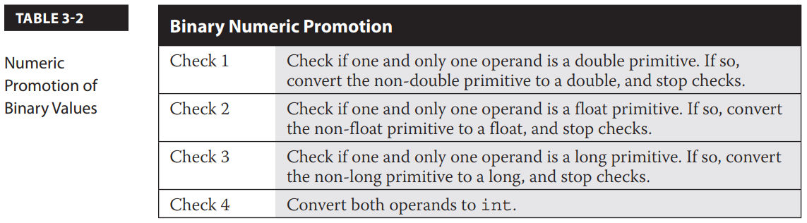

**Logical Operators**

Logical operators return boolean values. There are three logical operators on the exam: logical AND, logical OR, and logical negation.

|  |  |
| --- | --- |
| && | Logical AND (conditional AND) operator |
| || | Logical OR (conditional OR) operator |

The logical AND operator evaluates the left and right operands. If both values of the operands have a value of true, then a value of true is returned. The logical AND is considered a short-circuit operator. If the left operand returns false, then there is no need to check the right operator since both would need to be true to return true; thus, it short-circuits. Therefore, whenever the left operand returns false, the expression terminates and returns a value of false.

The logical OR operator evaluates the left and right operands. If either value of the operands has a value of true, a value of true is returned. The logical OR is considered a short-circuit operator. If the left operand returns true, there is no need to check the right operator, since either needs to be true to return true; thus, it short-circuits. Again, whenever the left operand returns true, the expression terminates and returns a value of true.

**Logical Negation Operator**